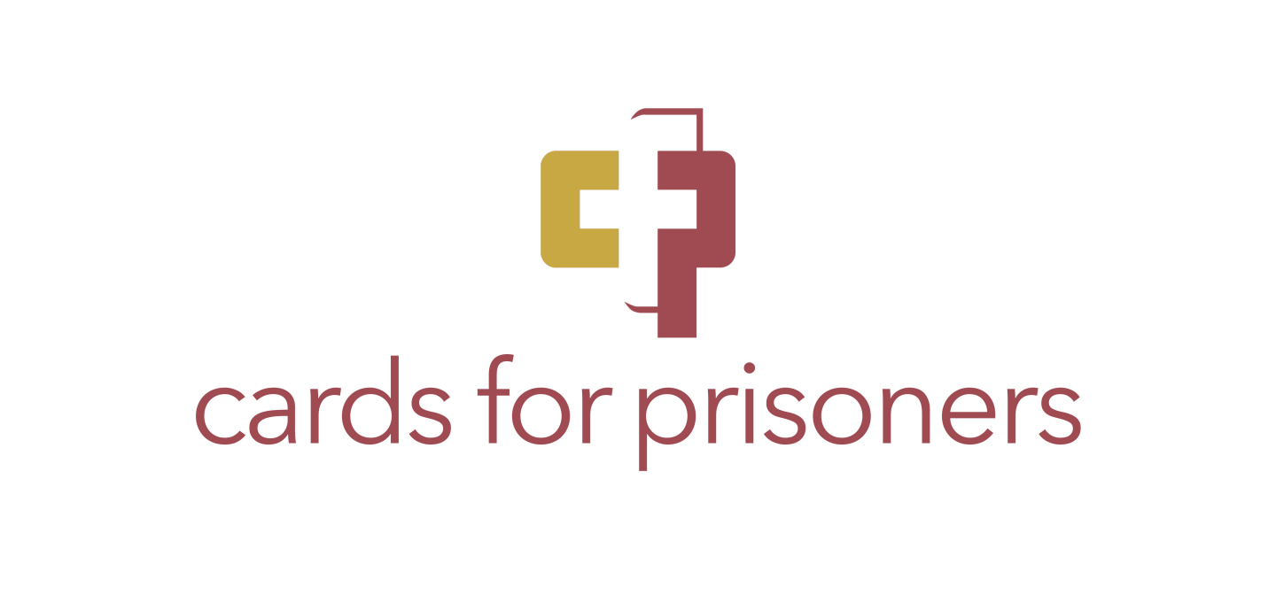

**Commonly Asked Questions**

***Please read carefully and sign***

**What kind of volunteers are we looking for?**   
People who are positive as well as creative, who would like to offer encouragement, guidance, and provide friendship to prisoners through cards.

**What kind of things do I write about?**Just be a friend. Talk about your interests, profession, or hobbies. Encourage them to talk about themselves. Many prisoners haven’t heard from anyone for years. They have dreams and interests that often go unheard.

**How often should I write?**At least once a month. We especially request that you remember to send a card for their birthday and the holidays. It takes approximately a week for them to receive mail, please keep this in mind when you are sending birthday/holiday cards.

**Is there an age requirement to volunteer?**   
Yes. All participants *MUST be at least 18 years old.*

**Will I know the crime the prisoner committed?**   
No. We feel strongly that this is their information to share if and when they feel comfortable. We also request you ***DO NOT look up their crime or google their name****.* We believe that no person should be defined by the worst mistakes and that *everyone needs someone* to remind them that God loves them and gives them value and purpose.

**Once a match is made, what information does Cards for Prisoners give the prisoner about the volunteer?**   
No information about the volunteer is ever given to the prisoner. This includes pictures of yourself and/or family members.

**Should I use a pseudonym when writing to a prisoner?**That depends on what makes you feel comfortable. Using a pseudonym does help to minimize whatever risk is involved in corresponding with a prisoner, but if you are comfortable with using your real name, that is fine. We want this experience to be as positive as possible for both the volunteer and the prisoner. *We do request you do not use your last name.*

**Do I have to give my home address?**NO! We require that you use your first name only and our P.O. Box 413 Grandville, MI, 49468. We will then forward the prisoner’s letter to you once we receive it. **When mailing your pen-pal be sure to include his/her prison number on the cards as well as the envelope, or it will be returned.**

**What rules should volunteers and prisoners follow?**

The prisoners are told our purpose and that we write for fellowship, friendship, encouragement, and spiritual growth, and not for romantic relationships or financial gain.

**How many prisoners may I write to?**As many as you can faithfully write to!

**My prisoner correspondent has written and asked for money. Should I send them a little money?**   
This is a question we receive from time to time, as prisoners often make this request. The necessities are provided for prisoners. The purpose of being a friend to a prisoner is to provide a friend with whom to exchange letters and words of encouragement. Please, do not send any money or gifts. Cards and letters only!

**My pen pal has told me that he is soon to be released and needs help in getting re-established. What can I do?**Once an inmate has their actual release date, they may contact us at our P.O. Box and we will connect them with resources in their area.

**What type of items can I mail to my pen pal?**Cards and letters. Please do not send pictures of yourself or your family.

God Bless you and thank you for reaching out to these beloved inmates that need your love and support! May you be blessed in being a blessing!!

**Safety Guidelines and Policies Agreement**

1. I will write to my pen pal at least once a month, including on his/her birthday and during the holidays.
2. I will remain anonymous with my pen pal and not provide my last name or any personal information about my family, including pictures.
3. I will post all my correspondence through the provided Cards for Prisoners PO Box.
4. I will send no financial or material goods to my pen-pal, or any members of his/her family.
5. I permit Cards For Prisoners to read the letters that my pen pal sends before they are mailed to me to make sure the content is appropriate.
6. I will not look up the crime(s) my pen pal committed or search for him on the internet or search for them on the internet.

I, ______________________________, do hereby confirm that I am at least 18 years old and agree to follow the above guidelines for writing to a prisoner. I confirm I have read and understand the guidelines above.

____________________________________ _________________________

**SIGNATURE and DATE E-Mail Address (for our use only)**

# ADDRESS:

# PHONE NUMBER: _____________________________________________________

**HOW DID YOU HEAR ABOUT CARDS FOR PRISONERS?** ________________________

**WOULD YOU LIKE A CARD STARTER KIT?____________**

**CHURCH AFFILIATION (if any)** _______________________________________________________

**MONTH AND DATE OF BIRTH_____________________________(year not necessary)**

**Info about yourself (to help match you with a pen pal).**